# Tutorial– 1

1. What are two main factors for measuring the performance of algorithm? Explain in brief.
2. (a) Write short note on Big O Notation.

(b)Define Asymptotic Notations.

3. What do you mean by pseudo code? What are the various parts of an algorithm? What are the various constructs of pseudo code?

4. Discuss various ways for representation of Sparse Matrices in memory?

5. Define Space Time Trade Off algorithm.

6. What is meant by term Row Major Order & Column Major Order in Array? How do we calculate the address of an element in a row major two dimensional array?

7. Consider the Linear Array aaa(5:50),bbb(-5:10) and ccc(18).

(a) Find the number of elements in each array.

(b) Suppose Base (aaa)=300 and w=4,words for memory cell for aaa. Find the address of aaa[15],aaa[35] and aaa[55].

8. Derive the Time Complexity of the linear search in average and worst case.

9. Since binary search is very efficient, why would one want to use any other search algorithm?

10. What does Abstract Data Type mean?

11. Advantage & Disadvantage of Binary Search & Linear Search.

# Tutorial – 2

1. Write the algorithm/program for the Push & Pop operations performed on stack.
2. Write short note on following :
3. Priority queue &how it is implemented in memory?
4. Dequeue
5. Application of queue and stack.
6. Multiple Stack
7. Multiple Queue.
8. Solve the following using free hand expression and using stack:

(i) a+[(b+c) + (d+e) ]+ f/ g

(ii) a+b+-c

(iii) a*b+c/d

(iv)(a+b)*c/d

(v) (a+b)*c/d+e^f/g

(vi) a+(b*c-(d/e^f)+g)*h

(vii) a-b/(c+d^e)

1. Convert infix to prefix using free hand expression and using stack.

(i) a+b&c

(ii) (a*b)+c

(iii) a/b^c+d

(iv) (a*b+(c/d))-f

1. Convert postfix to prefix :

4,2,$,3,*,3,-,8,4/,1,+/,+

1. Write algorithm/function for deleting an element form a queue which is represented using array.

# Tutorial – 3

1. What is difference between Stack, Queue & Linked List?
2. Define Doubly Linked List. Give algorithm to insert and delete element in it. What are advantages and disadvantage of this data structure?
3. Write an algorithm/program for inserting a node after given location in a Circular Linked List.
4. Write short note on :

(i)Recursion

(ii)Header linked list

(iii)How do you check whether a given circular linked list with header is empty?

1. Write a Recursion routine to find the number of nodes in a linked list.
2. Write a program to reverse a singly linked list without using any more memory.
3. Write a procedure to add two polynomials with the help of an example.
4. Write an algorithm/program to delete a node with value x from a singly linked list.
5. Define memory location operator new() ,malloc() & calloc().
6. Write an algorithm/program to count the number of elements in linked list.
7. What is Linked List? Representing diagrammatically & discuss the pros and cons of different types of linked lists.
8. What is Null Pointer?

# Tutorial -4

1. Generate binary tree for the following traversal :

INORDER : c,d,e,b,g,h,f,k,l,p,q,m,n,j,a,s,t

POSTORDER : e,d,c,h,g,q,p,n,m,l,k,j,f,b,t,s,a

1. Difference between strictly binary tree and complete binary tree with example.
2. Make binary tree :

PREORDER : g,b,q,a,c,k,f,p,d,e,r,h

INORDER : Q,B,K,C,F,A,G,P,E,D,H,R

1. Explain the following terms used in tree :
2. Terminal node /leaf
3. Right Successor & Left Successor
4. Sibling/Brother
5. Level number
6. Generation
7. Height/Depth
8. Degree
9. Ancestors & Descendent
10. How binary tree represented using
11. Array
12. Linked list
13. Explain Binary Tree Traversal.
14. Explain Overflow and Underflow condition in linked list?
15. Explain Threaded Binary Tree.
16. Explain Extended Binary Tree/2- Tree.
17. (i) Draw the expression tree for the following expression :

(a-3b)(2x-y)5+(e-j)3

(ii) Find the Preorder and Post order traversal of tree.

1. Consider the algebraic expression

E = (3a+b)(5x-y)2

(i) Draw the tree T which corresponds to the expression E.

(ii) Find the scope of the exponential operator i.e. Find the sub tree rooted at the exponential operator.

(iii) Find the Prefix Polish expression P which is equivalent to E & find the preorder of T.

# Tutorial – 5

1. Answer the following :
2. A tree is a directed graph (T/F).

(ii) The number of binary tree with N nodes is equal to ………………………

(iii) The number of arcs in the transitive closure graph of a strongly connected directed graph of N vertices will be ………………………….. .

(iv) A minimum spanning tree of a graph of N nodes will have ……………………………

(v) A binary tree with N node has exactly ………………………………. Branches.

(vi) How the resulting the binary search tree will look if the input sequence is already sorted in no decreasing order?

(vii) What are the limits of dijkstra’s algorithm?

(viii) Define internal sort.

1. Write down the algorithm for topological sort & explain it with the help of an example. What is it limitations?
2. Define the followings :

(i) Graph

(ii) Directed Graph

(iii) Connected Graph

(iv)Weighted Graph

(v) Cyclic Graph

(vi)Adjacent Graph

(vii) Complete Graph

1. Write down the algorithm to delete the node from a binary tree.
2. Draw the tree when the following nodes are deleted from binary tree shown in the figure

node A is deleted

node B is deleted

node C is deleted

Note : the nodes to be deleted in sequence

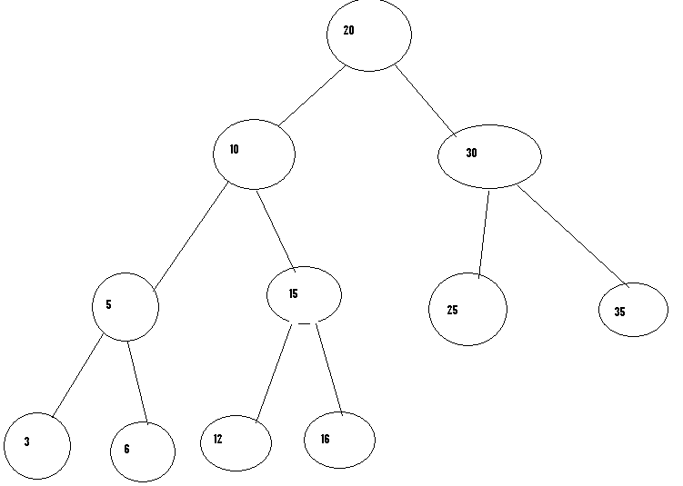

# Tutorial -6

1. What is spanning tree? What is a minimum spanning tree? Work out the kruskal algorithm to find the MSIT of the following graph:

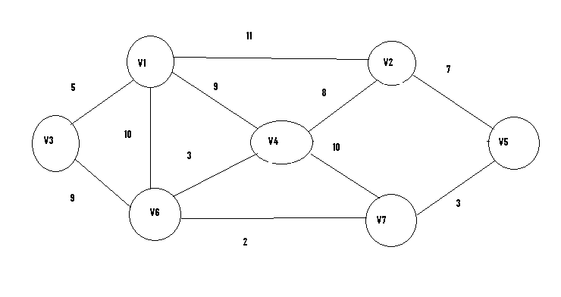

1. Write down the warshall algorithm & discuss its logic.what modifications did Floyd do to convert id into all pair shortest path algorithm?
2. Work out the dijkstra’s algorithm on the following graph.also enumerate each path :

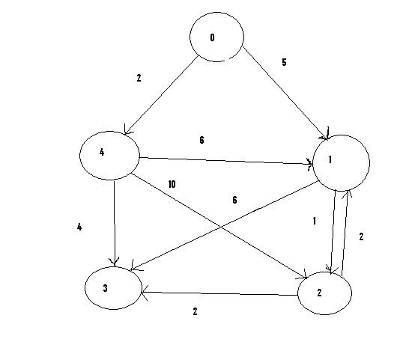

1. Why height balancing is required?

Create AVL tree

March,may,nov,aug,april,jan,dec,july,feb,june,oct,September

1. What is AVL tree?
2. Insert the keys in the order shown to behind on AVL tree A,Z,B,Y,C,X,D,W,E,V,F.
3. Find single source shortest path for the following graph using dijikstra algorithm taking ‘S’ as starting node.

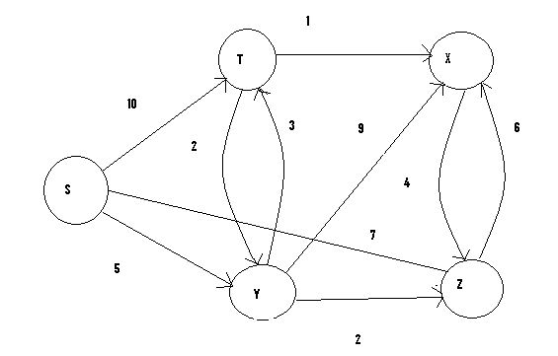

1. Find all pair shortest path for the following graph using warshall’s algorithm ( assume V1= R,V2=S,V3=T,& V4=U).

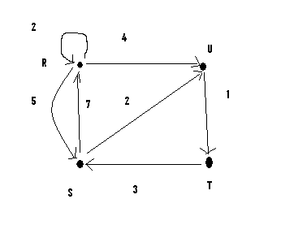

1. What is the difference between internal &external sorting?which sorting algorithm os preferred for external sorting?
2. Write down the comparisons in insertion sort for average & worst case?
3. What is balancing factor?why height balancing is required? Explain RL and LR rotation with example.

# Tutorial- 7

1. What is hash function? Consider a company with 68 employee assign a 4-digit employee number to each employee which is used as the primary key in the company’s employee file. Suppose L (set of memory addresses of the location) consist of 100 two – digit addresses : 00,01,02,…..99. Then apply the division method, mid square method and folding method (hash function) to find out the hash addresses for each of the following numbers 3205,7148,2345.
2. What is Heap Sort? Build a max heap for the following list of numbers: 44, 30,50,22,60,55,77,55.
3. Applying Merge Sort algorithm for the following list of numbers: 85,76,46,92,30,41,12.
4. Compare the complexities for the following sorting algorithm in average & worst case : bubble sort, quick sort ,heap sort
5. Write function of shell sort.
6. Explain the following :
7. 2-tree
8. 4-tree
9. Write short note on :
10. B –tree

(ii) M-way tree Search Tree

1. Partition Exchange Sort